Student Marking Application

User Manual

Developed by: Noah Shaffir

December 06, 2022

* Contents
  + Purpose
  + Languages and Technologies Used
  + List of Features
  + Clearing Past Results
  + Microsoft Word Report
* Purpose
  + The purpose of this application is to help professors make insights on their students’ performances in classes. It does so by generating statistics on the grades, visualizing this data, and putting statistics and a histogram in a Microsoft Word document report. This can help professors better understand how their students are performing overall in classes.
* Languages and Technologies Used
  + This application was developed using the following: Microsoft Word, Microsoft Excel, Microsoft Access, Visual Basic for Applications, and SQL.
* List of Features
  + Upon opening the application, the user is presented with 2 buttons and some instructions:
  + 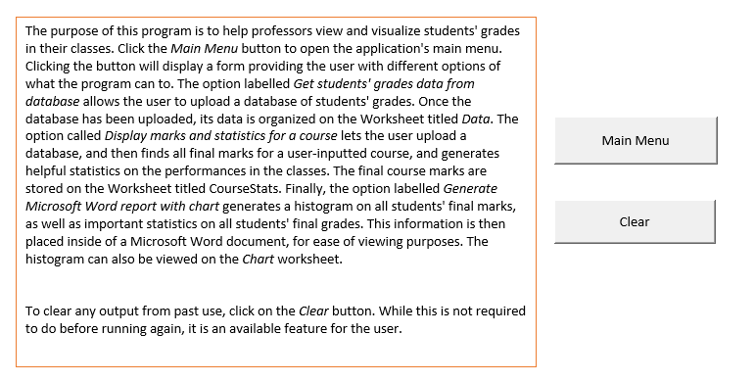
  + Clicking the *Main Menu* button displays the following form:
  + Graphical user interface, application

    Description automatically generated
  + The form can be exited by either the *Cancel* or *x* buttons. The user can select one of the features from the form and then click *Submit* to use that feature.
  + Selecting the button labelled *Get students' grades data from database* allows the user to upload a database of student marks, and then the program organizes this data in the worksheet labelled *Data*.
  + Selecting the button labelled *Display marks and statistics for a course* generates grade data on a specific course of the user’s choice. The user uploads a database and then inputs a desired course code. Then, all final marks for the course are stored in the worksheet labelled *CourseStats* and all the statistics generated on grades for that course are displayed to the user. A sample output is shown below:
  + Graphical user interface, text, application

    Description automatically generated
  + Selecting the button labelled *Generate Microsoft Word report with chart* generates a Microsoft Word document with a histogram showing students’ performances across all courses in the database, as well as statistics on all these final grades. Database data must be imported first, and the user is prompted to do so whenever this option is selected until it is done. When the chart is generated, it is stored on the worksheet *Chart* where it can be viewed. A sample output is shown below:
  + Chart, waterfall chart

    Description automatically generated
  + The above chart, as well as statistics on the final grades, can also be viewed in the Microsoft Word report document. A sample output is shown below:
  + Chart, waterfall chart

    Description automatically generated
  + Clearing Past Results
    - While it is not mandatory to clear results from a previous use before running the application again, a user might want to for the sake of convenience. As such, this feature has been included in the application.
    - To clear the contents of a previous output, click on the button labelled *Clear* on the *Instructions* worksheet. It is shown below as well:
    - 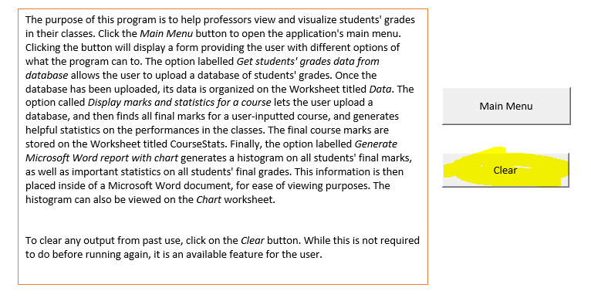
* Microsoft Word Report
  + The Microsoft Word report is stored as a .docx file in the same directory as the application.
  + It can be viewed in Microsoft Word, or any word processor capable of viewing .docx documents (although Microsoft Word is the preferred program).